
FACULTY OF INFORMATION AND COMMUNICATION TECHNOLOGY
PROG211: OBJECT ORIENTED PROGRAMMING 1
Title : Real World Solutions Under DPG Standards
Issue Date : Week 2
Due Date : Week 4
Name of Lecturer : Julius Laggah
Name of Student/s : Abdul Aziz Sesay
Student ID No. : 905005987
Class : BSEM1102
Semester/Year : 3/2
Academic Honesty Policy Statement
I/We, hereby attest those contents of this attachment are my own work. Referenced works, articles, art, programs, papers or parts thereof are acknowledged at the end of this paper. This includes data excerpted from CD-ROMs, the Internet, other private networks, and other people’s disk of the computer system.

Student’s Signature: Date:
LECTURER’S COMMENTS/GRADE:
for office use only upon receive
Remark
DATE :
TIME :
RECEIVER’S
RECEIVER’S

Table of Contents
1. Introduction 1
2. Problem Statement and Objectives 1
3. System Design 1
3.1 Classes and Responsibilities 1
3.3 Instance Methods and the Class Method 2
3.4 Required Functions 2
4. Program Features and Rules 2
5. Digital Public Goods (DPG) Standards 3
6. Program Execution 3
7. Testing 5
8. Limitations and Future Improvements 5
9. Conclusion 6
References 6

1. Introduction
This report accompanies the Python program StockGuard, my individual assignment for PROG211 Object-Oriented Programming 1. The assignment asks for a program that solves a real-world problem using classes and objects, one Python data structure, instance and class methods, and Digital Public Goods (DPG) principles. StockGuard is a simple menu-driven program that helps a small retailer keep product records, watch expiry dates, record stock losses and calculate how much money is lost.
The program uses only the Python standard library and runs in a terminal. Its code is split into three files: stockguard.py (the classes and functions), main.py (the menu) and test_stockguard.py (18 automated tests).

2. Problem Statement and Objectives
Small shops often track stock on paper. This makes it hard to know what is in stock, which products are close to their expiry dates, and how much money has been lost through expired or damaged goods. The target users are small retailers and shop owners in Sierra Leone and similar communities.
Objectives:
- Register products with quantity, unit cost and an optional expiry date.
- Show which products are expired or approaching expiry.
- Record losses caused by expiry or damage and reduce the stock correctly.
- Calculate the total money lost.
- Demonstrate classes, objects, a list, instance methods and a class method.

3. System Design

3.1 Classes and Responsibilities
The program has two classes. They are separate because one describes a single item and the other manages the whole collection.
Class | Attributes | Main methods
Product | product_id, name, category, quantity, unit_cost, expiry_date, loss_incidents, quantity_lost, loss_value | __init__(), expiry_status(), days_until_expiry(), record_loss(), stock_value(), __str__(); class method from_text(); static methods parse_quantity(), parse_cost(), parse_expiry()
StockLossTracker | products (the list), warning_days | __init__(), add_product(), find_product(), expiry_report(), record_loss(), total_loss_value(), summary(), set_warning_days()

Product handles one product: it checks its own values in __init__(), works out its own expiry status and records a loss against itself. StockLossTracker owns the list of Product objects and calls their methods. For example, tracker.record_loss() finds the product in the list and then calls product.record_loss(). This is the interaction between the objects.
3.2 Data Structure: the List
All products are stored in one Python list: StockLossTracker.products. A list was chosen because a small shop has a modest number of products, the order of entry is kept, and looping through a list to display or search is simple. No dictionary or second list is used. To find a product, find_product() loops through the same list. The loss history is kept inside each Product object (loss_incidents, quantity_lost, loss_value), so no second collection is needed. One tuple, LOSS_REASONS = ("expiry", "damage"), is used only as a fixed constant; it does not store product records.

3.3 Instance Methods and the Class Method
Instance methods work on one existing object through self. For example, milk.record_loss(5, "expiry") changes the quantity and loss totals of that Milk object only. Product.expiry_status() and StockLossTracker.find_product() are other examples.
Class method. Product.from_text() is decorated with @classmethod and receives cls instead of self. It is called on the class, before any object exists, and its job is to create a new Product from text typed by the user: it converts and validates the text and then calls the constructor. This is different from an instance method because there is no existing object to work on.

3.4 Required Functions
add_record(tracker, product) adds a Product object to the tracker's list and returns a confirmation message; it rejects duplicate IDs. display_records(tracker) loops through the list and prints each product in a table, or prints a message if the list is empty. Both functions work directly with the Product objects and the tracker's list.

4. Program Features and Rules
The menu offers: (1) add a product, (2) display products, (3) search by ID, (4) check expiry status, (5) record a stock loss, (6) show the loss summary and (7) exit. The main rules are:
- Dates use Python's datetime module in the format YYYY-MM-DD and are never compared as text. Products without an expiry date are allowed and are never expired.
- An expiry date equal to today counts as Expired. Approaching expiry means 1 to N days left (default N = 30, changeable in option 4).
- Quantity must be a whole number (0 or more); unit cost must not be negative; duplicate product IDs are rejected.
- A loss quantity must be above 0 and not more than the stock. An expiry loss is only accepted for a product whose expiry date has been reached; otherwise damage is used.
- Loss value = quantity lost x unit cost, calculated with Decimal and rounded to 2 places (currency label "Le"). A failed entry changes nothing.
- Records are kept in memory only and are lost when the program closes.

5. Digital Public Goods (DPG) Standards
Principle | What StockGuard does
Open source | The source code is plain Python, uploaded to a public GitHub repository under the MIT Licence.
Inclusive and accessible | Text-only menu that works with screen readers; plain English; numbered choices; clear error messages; no colour or mouse needed; runs offline on any computer with Python.
Privacy-respecting | No names, phone numbers or other personal data are asked for or stored. Only product data is used and nothing is saved or sent anywhere.
Modular | Logic, menu and tests are in separate files; each class and method has one job.
Reusable | stockguard.py contains no menu or input code, so it can be reused in other programs. The idea suits any shop or store.

These measures are my own implementation as a student project. The project has not been reviewed or certified by the Digital Public Goods Alliance.

6. Program Execution
The screenshots below are from running python main.py. Replace each placeholder with your own screenshot. The text underneath each is the output the program produced when tested on 27 October 2026.
Screenshot 1: Display all products after registration
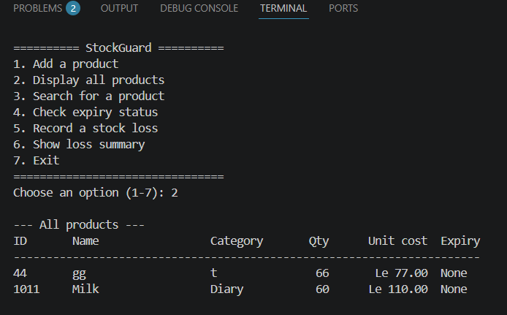
Screenshot 2: Check expiry Status
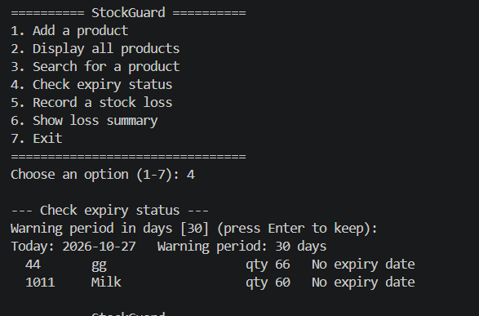
Screenshot 3: Main Source Code
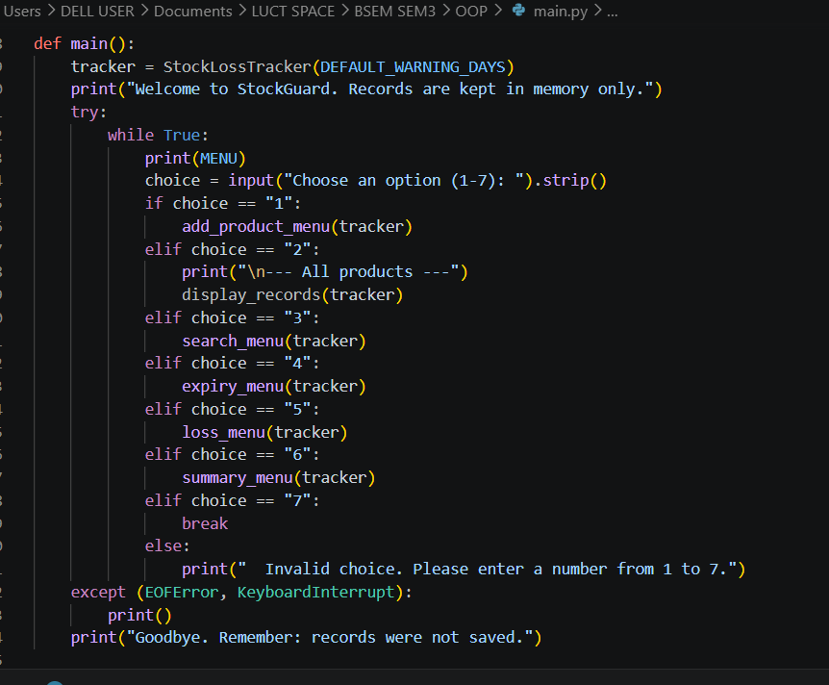

7. Testing
The 18 automated tests in test_stockguard.py were run with python -m unittest -v on Python 3.13. All 18 passed.
ID | Scenario | Expected result | Outcome
T01 | Add a valid product | Product added; ID stored as P1 | Pass
T02 | Duplicate product ID | Rejected; list unchanged | Pass
T03 | Display when empty | "No products registered" message | Pass
T04 | Search existing product | Product found | Pass
T05 | Search missing product | None returned | Pass
T06 | Expired product | Status: Expired | Pass
T07 | Product approaching expiry | Status: Approaching expiry | Pass
T08 | Product with no expiry date | Status: No expiry date | Pass
T09 | Far expiry date; expiry equal to today | Not yet in warning period; Expired | Pass
T10 | Custom warning period (5 days) | Status changes accordingly | Pass
T11 | Valid expiry loss (5 x 10.50) | Le 52.50; stock 15 | Pass
T12 | Valid damage loss (4 x 3.00) | Le 12.00; stock 46 | Pass
T13 | Loss greater than stock | Rejected; nothing changes | Pass
T14 | Invalid quantity or cost | ValueError for each bad value | Pass
T15 | Invalid dates | ValueError; empty means no expiry | Pass
T16 | Totals and final stock | Total Le 222.00; 3 incidents; stock 64 | Pass
T17 | Unknown product; wrong reason | Rejected | Pass
T18 | Class method from_text() | Valid product built; bad input rejected | Pass

The menu in main.py was checked by running it with scripted input; it is not covered by the unit tests.

8. Limitations and Future Improvements
- Data is stored in memory only and is lost when the program closes; the brief does not require saving.
- Individual loss events are not listed; only the totals for each product are kept.
- Products cannot be edited or deleted, and the unit cost cannot be changed after adding.
- Command-line only and one user at a time.
Possible future improvements (not implemented): saving records to a file, editing products, a list of individual loss events, reports by category and a Krio translation of the menu.

9. Conclusion
StockGuard shows how object-oriented programming can be applied to a real stock-control problem faced by small retailers. The program uses two classes: Product represents one item and manages its own expiry status and loss recording, and StockLossTracker manages the collection and coordinates the operations. All products are stored in a single Python list, and the required add_record() and display_records() functions work directly with it. Instance methods handle the actions on each object, while the @classmethod Product.from_text() creates new products from validated user input.
The program lets a shop owner register products, check which items are expired or approaching expiry, record losses from expiry or damage, and see the total financial loss. Dates are handled with datetime, money with Decimal, and every input is validated before any record is changed, so a failed entry never leaves the stock wrong. All 18 automated tests passed, and a scripted run of the menu produced a summary that matched the underlying records.
The project follows Digital Public Goods principles through an open-source licence, a text-only accessible interface, no personal data, a modular structure and reusable core logic. Its main limitation is that records are kept in memory and are lost when the program closes. Saving to a file and editing products would be the next improvements. Building StockGuard strengthened my understanding of classes, objects, methods and data structures, and how to explain them clearly.
If you want it in the Word report, I can add it as section 9 and move the GitHub section to 10, with the contents page updated. If you reframe the project as a health or agriculture tool, I'll adjust the wording to match.

References
Digital Public Goods Alliance (n.d.) Digital Public Goods Standard. Available at: https://www.digitalpublicgoods.net/standard (Accessed: 27 October 2026).
GitHub Docs (n.d.) Inviting collaborators to a personal repository. Available at: https://docs.github.com/en/repositories/managing-your-repositorys-settings-and-features/repository-access-and-collaboration/inviting-collaborators-to-a-personal-repository (Accessed: 27 October 2026).
Python Software Foundation (n.d.) Classes — The Python Tutorial. Available at: https://docs.python.org/3/tutorial/classes.html (Accessed: 27 October 2026).
Python Software Foundation (n.d.) The Python Tutorial. Available at: https://docs.python.org/3/tutorial/index.html (Accessed: 27 October 2026).

